标题：Innovation Strategy After IPO: How AI Analytics Spurs Innovation After IPO
作者及机构:
Lynn Wu: Operations, Information and Decisions Department, Wharton School, University of Pennsylvania, Philadelphia, Pennsylvania 19104
Bowen Lou: University of Connecticut, Storrs, Connecticut 06269
Lorin M. Hitt: Operations, Information and Decisions Department, Wharton School, University of Pennsylvania, Philadelphia, Pennsylvania 19104
摘要: We examine the role of AI analytics in facilitating innovation in firms that have gone through IPO. Using patent data on over 1,000 publicly traded firms, we find that firms acquiring AI analytics capability post-IPO experience less of a decline in innovation quality compared with similar firms that have not acquired that capability. This effect is greater when only machine learning capabilities are considered. Moreover, we find this sustained rate of innovation is driven principally by the continued development of innovations that combine existing technologies into new ones—a form of innovation that is especially well supported by analytics. By examining three main mechanisms that hampered post-IPO innovation, we find that AI analytics can ameliorate the pressure to meet short-term financial goals and disclosure requirements. However, it has limited effect in addressing managerial incentives. For firms with long product cycles, the disclosure effect is reduced to a greater extent than it is for those with short cycles. Overall, our results show the importance of examining technology as a critical input factor in innovation. We show that the increased deployment of AI analytics may reduce some of the innovative penalties suffered by IPOs and that investors and managers can potentially mitigate post-IPO reductions in innovative output by directing capital acquired in the IPO process to the acquisition of AI analytics capabilities.
AI标题: AI分析破解IPO创新衰退：技术重组型专利成突围关键
AI精炼: **AI分析如何破解上市公司的创新困局？** 该研究聚焦企业IPO后的创新战略，探讨科技公司上市后为何面临创新质量下滑的难题。传统解法如杠杆收购或并购不仅成本高昂，还可能因文化冲突失效（如戴尔退市案例）。论文通过分析1000+上市公司的专利数据，发现一个突破性解法：**AI分析能力能显著缓解创新衰退，尤其体现在技术重组型创新**。 有趣的是，AI并非万能——它对颠覆式创新作用有限，却能通过加速现有技术组合，有效对抗短期业绩压力与信息披露风险（如缩短研发周期降低模仿风险）。研究团队采用双重差分、工具变量等严谨方法验证：**机器学习能力每提升1%，企业技术重组专利增加0.7%**。这一发现为上市公司指明新路径：将IPO募资投向AI人才建设，比传统财务重组更具性价比。 （字数：229）
关键词:
双重差分法(DID)
工具变量法(2SLS)
Heckman两阶段估计
倾向得分匹配(PSM)
技术重组型创新
专利子类分析
创新质量指标
学术要点: 学术要点 1：组合式创新（New Combination Innovation） 通过重新组合现有技术形成的创新类型，区别于完全突破性创新，是AI分析能力最显著支持的创新路径。|||
学术要点 2：创新质量衰减机制（Innovation Quality Attenuation Mechanism） IPO后由短期主义压力、强制披露要求和管理层激励稀释构成的三维机制，其中前两者可通过AI分析能力缓解。|||
学术要点 3：技能网络测度（Skill Network Measurement） 基于员工简历数据和岗位评论构建的AI分析能力量化方法，通过职业轨迹映射企业技术吸收能力。|||
学术要点 4：专利局部/全局新颖性（Local/Global Novelty） 基于USPC专利子类划分的二元创新分类框架，区分企业内部首次应用（局部）与行业首创（全局）的技术突破。|||
学术要点 5：内生性处理架构（Endogeneity Correction Framework） 综合使用倾向得分匹配（PSM）、Heckman两阶段模型与工具变量法（HCM/ERP网络），解决技术投资与创新产出的双向因果问题。
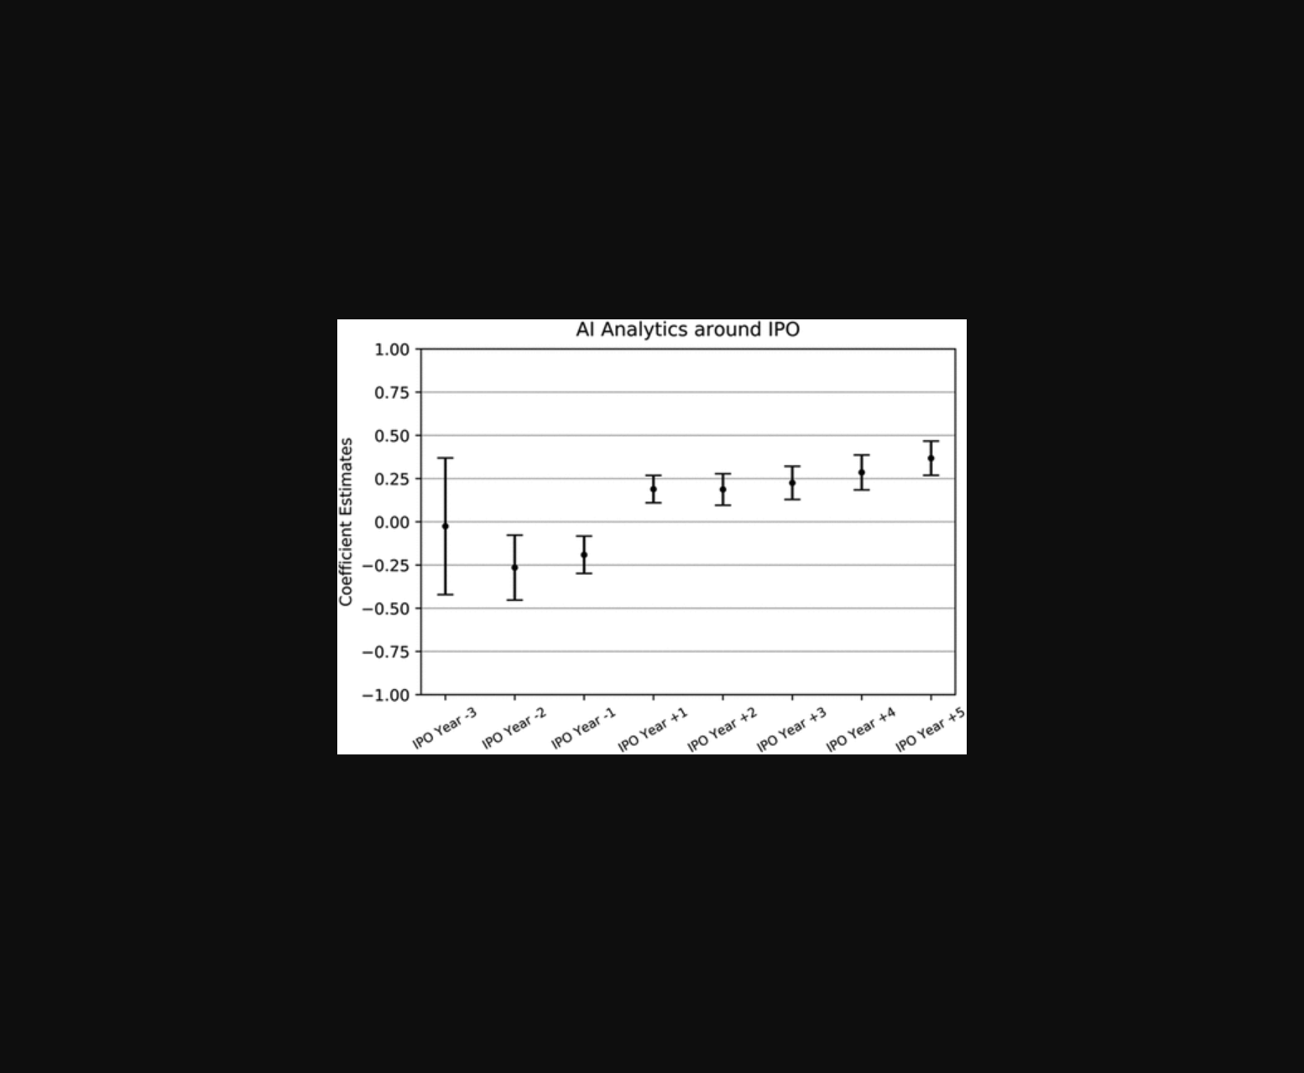
该图对比了IPO后具备与未具备AI分析能力企业的创新质量变化趋势。

图片对比了IPO后采用与未采用AI分析企业的创新质量变化趋势。

未找到图片描述。

未找到图片描述。

未找到图片描述。
原文链接: https://doi.org/10.1287/mnsc.2022.01559

